**BEFORE THE UPPER HUTT CITY COUNCIL**

**UNDER** Plan Change 47 – Natural Hazards AND

**IN THE MATTER** the Proposed Upper Hutt City Council District

Plan

**STATEMENT OF EVIDENCE OF**

**SARAH ALICIA MARTIN / DAVID ALLEN SULLIVAN 19 MARCH 2024**

# QUALIFICATONS AND EXPERIENCE

## Sarah Martin

* 1. My name is Sarah Alicia Martin. I am a Senior Engineering Geologist at Tetra Tech Coffey (NZ) Ltd. I have 12 years’ experience as an engineering geologist in the Wellington region.
  2. My qualifications are Masters of Science (Geology) from Victoria University of Wellington, Batchelor of Science (Geology, Geography) from Victoria University of Wellington. My experience includes assessing natural hazards and the impacts of these in a number of settings including undertaking natural hazard assessment for suitability of subdivision, liquefaction and soft ground assessment for individual properties, land damage assessments for liquefaction and slope failure and fault assessment studies.
  3. My involvement in the Plan Change was providing geotechnical hazard assessment and input into PC47 and managing Tetra Tech Coffey (NZ) Ltd involvement in the project, including liaising with UHCC, undertaking most of the site visits, written or provided input into Tetra Tech Coffey’s reporting and assessment and reviewed the final maps.

## David Sullivan

* 1. My full name is David Allen Sullivan. I am employed as a Principal Geotechnical Engineer at Tetra Tech Coffey (NZ) Limited (Tetra Tech Coffey), Tauranga, New Zealand. I am a Chartered Geotechnical Engineer in New Zealand and am registered as a licensed Civil Engineer in the seismically active states of California and Nevada. I am a Tetra Tech Coffey Authorised Reviewer having been vetted by Senior Principals to perform technical reviews. I am a member of the following organisations: New Zealand Geotechnical Society (NZGS); Geoscience Society of New Zealand, Engineering New Zealand; and Association of Environmental and Engineering Geologists (AEG).
  2. I have a Bachelor of Science in Geological Engineering from Mackay School of Mines (University of Nevada) and a Master of Business Administration from University of Phoenix.
  3. I have over 27 years of experience in the geotechnical and geological consulting industry. My experience has been in Nevada, California, and New Zealand. I practice as a geotechnical engineer with specialty in geologic hazards, including (but not limited to) liquefaction, slope stability, fault studies, and subsidence. I have numerous years of fault investigation experience. Notable projects include geotechnical and geological services for Waikato Expressway, The Lake Subdivision, Kenepuru Landing Subdivision, IAG Christchurch Recovery, and IAG EQC slope assessments.

## Code of Conduct

* 1. I confirm that I have read the Expert Witness Code of Conduct set out in the Environment Court’s Practice Note 2023. I have complied with the Code of Conduct in preparing this evidence and agree

to comply with it while giving oral evidence. Except where I state that I am replying on the evidence of another person, this written evidence is within my area of expertise. I have not omitted to consider material facts known to me that might alter or detract from the opinions expressed in this evidence.

## Potential Conflict of Interest Declaration

* 1. I would like to note one potential perceived conflict of interest associated with this plan change. Tetra Tech Coffey previously provided geotechnical review of the foundation design at 102 Katherine Mansfield Drive for the O’Brien Family Trust via intermediary engineering and contractor firms. This work was undertaken by our Auckland office, and I have not been involved with this work.

# MANGAROA PEAT OVERLAY

* 1. Within my evidence, drawing on my experience in these matters, I provide supporting information and advice with respect to the geotechnical hazard of peat ground conditions. I will provide some context as to why peat is a specific hazard, the methodology and assessment that was undertaken to arrive at this map extent, the nature of adjustments and revisions to this extent that were made based on site visits and other considerations raised by submitters.

## Why is the peat a hazard?

* 1. Peat is considered a geotechnical hazard because these ground conditions are soft and organic. It is well documented that peatland settles over time which is expected to result in ground settlement. The peat in Mangaroa is a loose accumulation of organic matter in a former swamp. It is highly compressible, as under load the peat compresses as water is readily squeezed out of it. Organic matter also decays with time, leading to further settlement. This hazard is not dependent on an event (such as an earthquake) occurring, but from loading by a building or earthworks fill. Ground settlement can result in differential settlement that impacts the structural integrity of a dwelling.
  2. Additionally, during an earthquake, consolidation of peat soils can result in large settlements. Observations from the 2010-2011 Christchurch earthquake sequence noted settlements of ~300mm. Peat soils can also amplify the ground shaking leading to greater structural damage. Loose, saturated peat in a basin setting can be expected to cause large amplification of earthquake surface wave motions when the shaking intensity is low. At high shaking intensity the weak peat soils will tend to yield and may reduce ground motions. However, basin edge effects which have been observed recently in earthquakes, may also cause amplification.
  3. The peat at the Mangaroa Peatlands is ~6m thick in the south and due to natural gradients of the peatlands, likely increases to ~15m in the north. This likely thins to the margins. Building platforms have been identified adjacent to Katherine Mansfield Drive along the south-east margin.
  4. The degree of anticipated ground settlement is dependent on the depth, thickness and characteristics of peaty soils. Even relatively thin (<0.5m) bands of peat can be problematic for building foundations if not appropriately identified and accounted for in foundation design. Therefore, a site-specific

subsurface investigation to enable characterisation of the ground conditions and specific engineering design of the foundations would be recommended in areas of suspected peat. This would mitigate the hazard posed by the peat to a future dwelling being constructed on a near allotment.

## Process involved in mapping the peat

* 1. The Mangaroa Peatland area in the Upper Mangaroa Valley was identified as a geotechnical hazard as part of mapping by Tetra Tech Coffey as input to Plan Change 47 – Natural Hazards in 2020. The extent of this peat hazard area was determined based on the area mapped as peat in the Geology of Wellington 1:50 000 Map1. Borehole data available on the New Zealand Geotechnical Database (NZGD) in the area was reviewed, as well as previous studies on the Mangaroa Peatlands produced by GNS . A visit to the area and visual observation of the peatland area from public areas was undertaken at this time.
  2. During the pre-notification consultation process, some residents were contacted relating to the location of the Mangaroa Peat Overlay on their property. A site walkover with access to relevant properties was undertaken on 21 December 2021, 25 January 2022 and July 2022 to refine the southern boundary of the peatland extent. Adjustments to the peat boundary were made based on visual observation and discussion with land owners where they could provide additional information that was consistent with site observations and the criteria in paragraph 2.8. An additional site visit was undertaken in August 2023 in response to submissions. Where sufficient evidence that areas were not peat could be established, the hazard map was refined to reflect this.
  3. The following key criteria was the basis of the adjustment of the peat extent following the site visits in 2021 and 2022. These adjustments were made area wide where appropriate (affecting properties that weren’t specifically visited) as detailed below.
     + Exposed ground: Where the upper soil profile (below any topsoil) was able to be viewed (for example via cuttings or pits), this was used to confirm the presence or otherwise of peat at that location.
     + Slope angle: The peat area is characterised by flat topography, with some gentle slopes around the margins. Therefore, areas that were moderate to steep were generally excluded from the peat extent.
     + Discussions with property owners: Where there was information provided about soil behaviour or conditions from property owners experience that was in line with site observations this was used to refine the peat extent boundary. Where observations from property owners did not have any supporting evidence, changes to the peat extent were not made.
     + Soil maps: The existing peat extent and site observations were compared with the soil maps2 . In particular,

the NZSC Soil Order where those soils mapped as Brown or Ultic soil were generally considered outside

1Begg, J.G.; Mazengarb, C. 1996. Geology of the Wellington area: sheets R27, R28, and part Q27, scale 1:50,000. Institute of Geological & Nuclear Sciences geological map 22. Institute of Geological & Nuclear Sciences, Lower Hutt. 128 p. + 1 sheet.

2 S-Map Online Manaaki Whenua Landcare Research <https://smap.landcareresearch.co.nz/maps-and-tools/app/> accessed February 2022

of the peat extent and soil drainage where moderately and well drained soils were generally considered outside of the peat extent.

* + - Existing geotechnical data available from UHCC records or provided by land owners was also reviewed for relevant geology or geotechnical data that could aid in refining the edge of the peat hazard extent.

## Site visits undertaken, and identifying where adjustments were made

* 1. Twenty properties were visited at the request of property owners as part of the pre-notification consultation and submission process. Based on a visual site walkover and where sufficient evidence from the visual observations was noted, the boundary of the peat hazard area was refined in line with the criteria in paragraph 2.8. Adjustments to the identified hazard area were made where the site visit indicated that peat was most likely absent from an area where it was currently mapped. Those properties visited and whether the peat boundary was adjusted on the property is noted in Table 1 below and a map of those properties visited is shown in Figure 1 below.

**Table 1: Summary of site visits and adjustments made in relation to the peat hazard**

|  |  |  |  |
| --- | --- | --- | --- |
| **Address** | **Site Visit** | **Purpose of Visit** | **Adjustment Made** |
| 50a Katherine Mansfield Drive | 21/12/2021 | Peat | Y |
| 50b Katherine Mansfield Drive | 21/12/2021 | Peat | Y |
| 50c Katherine Mansfield Drive | 21/12/2021 | Peat | N |
| 50d Katherine Mansfield Drive | 21/12/2021 | Peat | N |
| 50e Katherine Mansfield Drive | 21/12/2021 | Peat | Y |
| 102 Katherine Mansfield Drive | 21/12/2021 | Peat | N |
| 110 Katherine Mansfield Drive | 21/12/2021 | Peat | Y |
| 156 Katherine Mansfield Drive | 21/12/2021 | Peat | Y |
| 159 Katherine Mansfield Drive | 21/12/2021 | Peat | Y |
| 191A Katherine Mansfield Drive | 21/12/2021 | Peat | Y |
| 244 Katherine Mansfield Drive | 21/12/2021 | Peat | N |
| 165a Katherine Mansfield Drive | 25/01/2022 | Peat | Y |
| 281A Katherine Mansfield Drive | 25/01/2022 | Peat | N |
| 2 Margaret Mahy Drive | 25/01/2022 | Peat | N |
| 74 Katherine Mansfield Drive | 26/07/2022 | Peat | Y |
| 74a Katherine Mansfield Drive | 26/07/2022 | Peat | N |
| 76 Katherine Mansfield Drive | 26/07/2022 | Peat | Y |
| 96 Katherine Mansfield Drive | 26/07/2022 | Peat | N |
| 230 Katherine Mansfield Drive | 25/08/2023 | Peat and Slope | N |
| 3 Ashton Warner Way | 25/08/2023 | Peat | N |

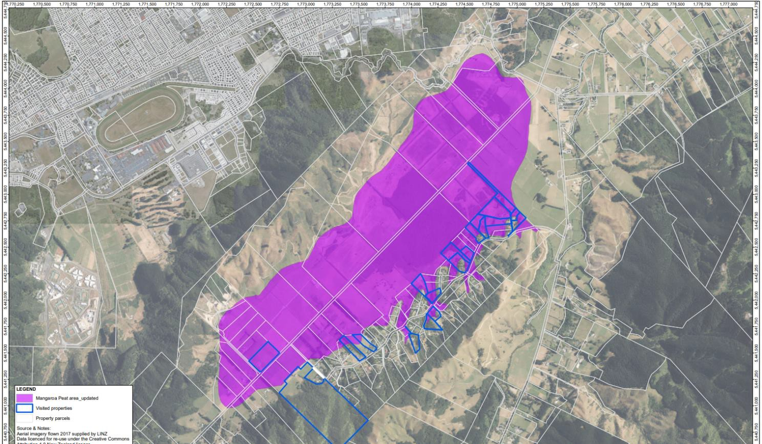

**Figure 1: Properties visited within the mapped peat hazard area**

* 1. 29 additional properties that were not specifically visited or provided submissions also had a peat hazard adjustment that affected them. This was due to evidence indicative of non-peat ground conditions, such as topography, extending beyond the property boundaries of those properties specifically visited. A map showing the changes to the southern extent of the peat hazard extent is shown in Figure 2 below.

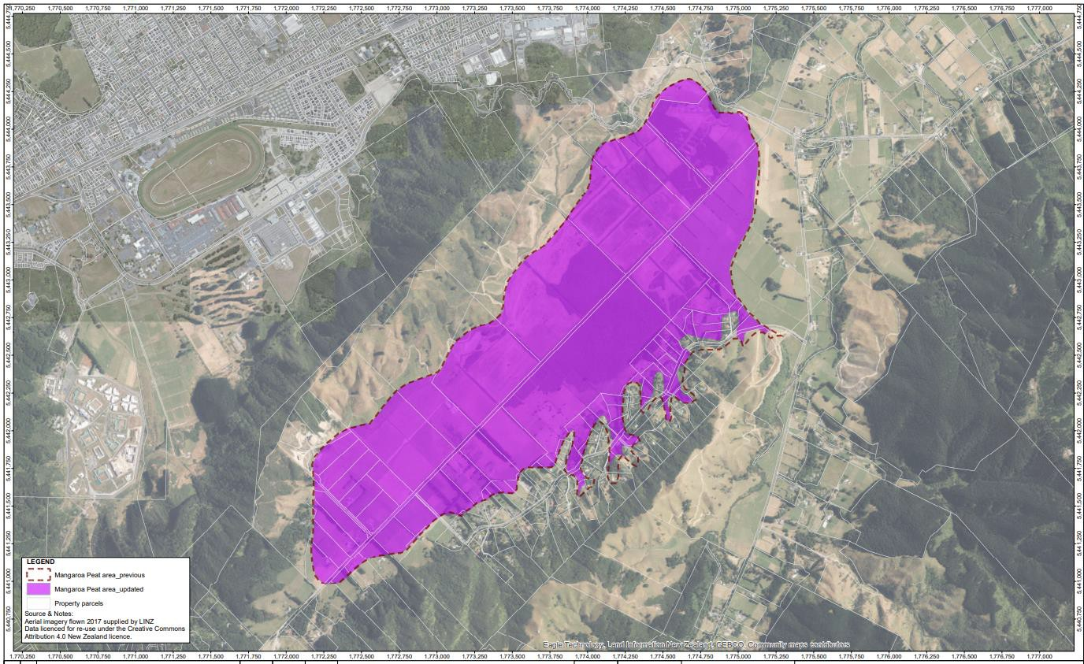

**Figure 2: Changes to the peat hazard extent along the southern margin in 2022. From “Changes to peat hazard extent” map, dated 19/08/2022, Tetra Tech Coffey**

## Mapping Robustness

* 1. The intent of this mapping is to identify where peat is potentially a hazard for UHCC to assess at the time subdivision.
  2. The mapping identifies the likely area of peat based on available information and site walkovers. This is suitable for an area wide assessment that identifies the likely area of peat and therefore the geotechnical hazards associated with developing on this soil type. Site specific geotechnical assessment of these sites is prudent to assess the presence, thickness and nature of peat and therefore the effects on a proposed building platform. This will enable dwellings to be located on suitable foundations, or be located on more suitable ground conditions.
  3. Specific design of foundations for dwellings founded in areas of peat is critical to mitigate the hazard on building on this type of soil. Without this, structural damage to dwellings under by static conditions from loading of this soil type with the dwelling and seismic conditions in the event of an earthquake are likely.
  4. It is not intended as a site specific assessment of the ground conditions on a specific property, but reflects areas likely to be affected by this hazard and therefore assessment of the hazard by an appropriately qualified geo-professional is recommended.
  5. The mapping has been completed at a suburb-wide scale and is suitable for use at a 1:10,000 scale. These maps do not constitute a site-specific assessment of each property within and adjacent to the identified hazard area. But indicate the extent of peat and the hazard associated with building on these ground conditions.

## Alternative soil map raised by submitters

* 1. We note that a number of submitters reference a report and associated soil map “Soils of Mangaroa- Whitemans Valley, Upper Hutt, New Zealand”3 (Map in Figure 3 below). This map identifies an area of organic soil ‘Mangaroa soils (Mp) in the centre of the valley which is smaller than the peat hazard overlay. The organic soil is surrounded by ‘Gollans soil’ (G) and Gollans soil peaty layers (Gp). With some poorly drained loam soils, Heretaunga pale (Hm) and Wainuiomata (W), as well as fingers of well drained terrace remnant soils (J – Judgeford) soils near the southern margins. The majority of the area identified as a peat hazard is within the Mp or Gp soil type and some areas at the south-western extent of the peat hazard mapped as in the G soil type.

3 Heine, J.C.; McQueen, D. 2020. Soils of Mangaroa–Whitemans Valley, Upper Hutt, New Zealand. Unpublished report produced for Upper Hutt City Council.

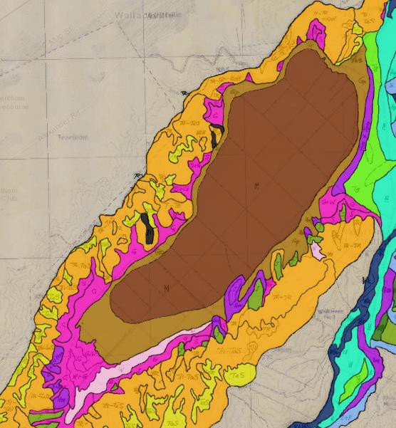

**Figure 3: Mangaroa Valley Soils map.** [**https://www.arcgis.com/home/webmap/viewer.html?webmap=e3d86334fa9f4157a142d4f5c189c856**](https://www.arcgis.com/home/webmap/viewer.html?webmap=e3d86334fa9f4157a142d4f5c189c856)

* 1. The Mangaroa Valley Soils map (Figure 3) is similar to, but more detailed compared with the Manaaki Whenau NZSC Soil Order map4, which Tetra Tech Coffey reviewed as part of the 2022 refinement of the peat hazard layer. In the Mangaroa Valley Soils map, the Mangaroa soils are equivalent to Organic soil and Gollans soil equivalent to Gley soil in the Soil Order map.
  2. The mapped Organic/ Mangaroa soils are an under-representation of the peat soils in the Mangaroa Valley and therefore not appropriate to be used directly as the limit of the geotechnical peat hazard for the following reasons:
     + The Gollans soil peaty layers (Gp) is noted to contain some peat within the soil profile (up to 50%).
     + Publicly available geotechnical investigation data indicates that peat is present to 3m and 6m depth outside of the mapped Organic/ Mangaroa soil layer .This is consistent with the

4 S-Map Online Manaaki Whenua Landcare Research <https://smap.landcareresearch.co.nz/maps-and-tools/app/> accessed February 2022

anticipated thinning of the peat layers towards the margins, but that the presence of peat and the associated geotechncial hazard extends beyond the mapped Organic/ Mangaroa soil unit.

* + - The soil mapping typically relates to the upper 100cm of the ground profile. The main purposes of this mapping relates to soil productivity, suitability for septic tanks and sensitivity to run off or leaching, rather than geotechnical hazard and foundation suitability. Peat layers at depths significantly deeper than 1m can cause significant damage to a dwelling if not appropriately accounted for in foundation design.
    - Peat soils are expected to be interbedded and/or buried with other soil types, especially near the margins of the hazard area. Areas with the potential for any peat can pose a geotechnical hazard to dwellings if not appropriately accounted for in foundation design.

## Additional comments on submissions not covered above

* 1. Some submitters commented on having additional risk levels. This was considered while working through this assessment. However, it was considered more appropriate as a single overlay to identify the area of anticipated peat to have a geotechnical risk. As the purpose is to identify areas that require additional assessment, including different grades of hazard such as a medium hazard area would not have a meaningful impact on the requirements, as further investigation would be recommended for any areas of anticipated peat. These additional risk levels would introduce additional, unnecessary complexity to the process.

# HIGH SLOPE HAZARD

* 1. Within my evidence, drawing on my experience in these matters, I provide supporting information and advice with respect to the geotechnical hazard of high slope hazard. I will provide some context as to the methodology and assessment that was undertaken to arrive at this map extent. I will also provide some background to certain decisions that were made at the time of the provisions being drafted and the nature of adjustments to this extent that were made based considerations raised by submitters.

## Initial process in mapping the hazard

* 1. Tetra Tech Coffey were initially engaged by UHCC in 2019 to assess the geo-hazards in nine selected areas around Upper Hutt, including the Existing Urban Area. A more general, high level assessment of the slope hazard in the Kaitoke Valley, South Whitemans Valley – Blue Mountains areas, was also requested. In 2020, the slope hazard assessment was extended to include the Akatarawa Valley, Moonshine Valley and Remutaka Hill area as mentioned in Paragraph 3.8. This was to inform a review of the District Plan and provide information on geotechnical hazards for new or continued residential

development in these areas.

* 1. The slope hazard assessment initially considered slope angle, geology, evidence of shallow groundwater and signs of historic failure. This was refined further to slope angle and slope type (soil vs rock) based on the available city-wide data for the most significant factors influencing slope stability. Available geology maps, intrusive geotechnical data and slope angle maps were assessed as part of this project. Vegetation was not considered as this is not a permanent feature of the slope and removal of vegetation can change slope stability aspects of the slope. The slope hazard assessment recognises that items such as an increase in soil moisture during wet seasons or seismic events can trigger slope instability on steeper slopes.
  2. Site visits around the initially identified nine development areas, was undertaken to visually assess these landscapes were undertaken.
  3. Soil and rock slope types were initially assessed. The depth of colluvial soils and completely weathered rock on top of the greywacke rock mass can be variable from thin to very thick. The thickness of the soil layer on top of the rock will control the stability and behaviour of a slope. Therefore, if the thickness of soil on the rock mass is unknown, or more than 2m deep, the slope is regarded as a soil slope, even though there is greywacke rock underlying it. It is anticipated that in Upper Hutt, most slopes, including those mapped as rock, will have a mantle of soil of variable thickness overlying the rock. Without the data to assess this thickness area-wide, and with the rock slope case expected to be uncommon in Upper Hutt, the slopes were all assessed as soil slopes. While this is a conservative approach, it is reasonably so, considering the nature of slopes in the wider Wellington area and the available information.
  4. Based on the above and in the interest of having a simple, easily applicable classification system, we have defined high hazard slopes as being greater than 26 degrees. Natural soils and rock within Upper Hutt District for this study are regarded as generally stable up to a 26 degree slope angle. For natural slope angles greater than 26 degrees slope instability might occur, with increasing likelihood of instability as the slope angle increases. Slopes up to 26 degrees would not require a specific site stability assessment or a setback. However, ground with slope angle greater than 26 degrees would require a specific stability assessment from a geo-professional prior to development.
  5. To implement this, Land Information New Zealand (LINZ) datasets were downloaded from the LINZ data service in 2019. The slope hazard map was generated based on LiDAR 1m digital elevation model (DEM) of the Wellington region captured in 2013. These were clipped to the project area and used to generate a digital slope map. From this, slopes of 26 degrees or greater were identified as high slope hazard.
  6. A series of slope hazard updates occurred at the request of UHCC following the main package of works during 2020 and 2022. These updates were incorporated into various revisions of the slope hazard maps. This included the following:
     + Increase the area to be assessed to cover Akatarawa Valley, Moonshine Valley, Remutaka Hill and wider Upper Hutt City areas.
     + Smooth the high slope hazard layer for the entire area of assessment to remove the pixelated nature of the slope hazard layer as well as any stray items picked up incidentally in the LiDAR data such as large buildings. This was done manually to best capture the nature of the slopes, and at a high level, city-wide scale.
     + Remove slopes related to river and stream banks within 20m either side of these features. These were excluded from the high slope hazard as development adjoining rivers or streams is excluded from development as per the Operative District Plan SUB-GEN-R2 and associated standard SUB_GEN-S1. Where small streams are present at the base of a larger change in topography, the large slope was included as a high slope hazard as the streams are likely secondary to the slope. Where possible, the stream channel and banks were been removed from the high slope hazard overlay.
     + In October 2021, 126 potentially medium and high density sites that overlap with high slope hazard areas were re-assessed due to the central government direction to intensify development in some areas. These sites were assessed using the new (2021) LiDAR data on a site-specific basis at the request of UHCC.
     + August 2022: Revision of nine specific areas across Upper Hutt at the request of UHCC, where the slope angle maps looked to have oddities. These specific areas were assessed using a deskstudy approach including looking at contours, geomorphology and geology of these areas. This resulted in refinement of eight of these areas. These changes related to the inferred slope being a stream bank, or refinement of the high slope hazard once assessed at a closer scale.

## The refinement to the mapping following submissions

* 1. The slope hazard mapping was refined following the submissions in 2023. The mapping was reassessed and new LiDAR data from 2021 was used. This data was more accurate than the previous LiDAR data and produced a more accurate elevation data on suburb wide level (rather than city-wide as previous data had). This was therefore able to produce a better representation of the slope angle.
  2. Using the new 2021 LiDAR data significantly improved the slope angle map. Additional GIS rules to process the data were also applied to this to further refine and smooth the mapping. These included:
     + Analysis of footprints (as per UHCC and LINZ source) building platforms to identify the structures that have picked up high slope hazard and removed the high slope hazard from these structures. This was in response to the submissions. It is generally considered that most of the building platforms will be on flat or gently sloping land, or have been specifically designed.
     + Removal of areas where high slope hazard is ~49m2 in size and filled in spaces between high slope hazard ~49m2. This area is equivalent to ~1 pixel in the GIS assessment and therefore too minor to be significant on a suburb wide scale.
     + Removal of slopes less than 1.5m high. These slopes are too low to be considered a geotechnical hazard.
     + This analysis was clipped to the previous high slope hazard extent, as new areas are not able to be introduced at this stage, even if identified by higher resolution mapping. However, we understand these will be included in a future plan change.
  3. During the GIS analysis, site visits by UHCC and Tetra Tech Coffey were undertaken to 230 Katherine Mansfield Drive, 5 Margaret Mahy Road, 178 and 216 Mangaroa Valley Road which had a mixture of sloping and flat ground to field-check the mapping progress. It was generally found the revised maps picked up the field-observed slopes appropriately.
  4. Revised map produced by UHCC was reviewed by Tetra Tech Coffey in the GIS platform. Minor adjustments were made based on this, but the map was generally considered to be representative of the slope hazard on a suburb-wide scale.

## Robustness of the High Slope Area Maps

* 1. The slope hazard maps are suitable as a planning tool to assess those slopes most at risk of potential slope instability. This is an appropriate level of assessment for a plan change and is an area-wide assessment intended as a screening tool to assist UHCC in identifying where a potential slope hazard may exist. This assists UHCC to identify potential hazards so they can be managed, investigated further by a geo-professional and appropriate mitigation measures can be implemented, if required.
  2. In earlier iterations of the slope hazard mapping, removal of the stream banks was undertaken as per Section 3.8 above. Some stream banks remain within the hazard mapping, due to these banks being over

1.5m high and a digital misalignment of mapped water courses with actual contour data, which is inherent in the nature of this data. While these stream banks and nominated setbacks will also be covered in existing provisions as discussed in Section 3.8 above, they do also represent a slope hazard. Removal of these across the board risks leaving small sections of hazard that don’t provide a clear picture for UHCC. Removal of inconsequential slopes due to shallow stream channels and culverts have been addressed by removing slopes lower than 1.5m high and spot checking these on the resulting maps. The mapped stream channel centre-lines also line up poorly with the stream channel topography in many places. Removing these with a 20m GIS rule across the board, may result in un-intended areas being removed from the slope hazard area. On the balance of these considerations, leaving the stream channels without additional

modification was determined to be preferred.

* 1. Revision of the map with the updated LiDAR data has led to some inconsistencies, as this revision could only reduce the slope hazard area. In places, the revised map shows a shift in the high slope hazard, however only removal of the relevant area is appliable at this stage. This affects minor areas and does not undermine the suitability of the map for planning purposes. This is appropriate for a plan change and the purposes of identifying areas of an elevated slope hazard that warrants further assessment. Consideration of including additional criteria introduced additional complexities that existing information is not well placed to assess on a city-wide scale. Therefore, with the level of information we have available, this approach is the best way to capture those slopes that may pose a hazard for further development, if no site-specific specialist assessment is undertaken.
  2. The mapping has been completed at a suburb-wide scale and is suitable for use at a 1:10,000 scale. The maps should not be used as a geotechnical assessment for a specific property. The maps are appropriate to inform a plan change, but further investigations would be needed on a site by site basis. These maps do not constitute a site-specific assessment of each property within and adjacent to the identified hazard area. But indicate areas of high slope hazard that require additional assessment.
  3. This hazard map is based primarily on 2021 LiDAR data, so changes to the ground profile from modifications will not be reflected in this assessment.
  4. Some submitters referred to the Manaaki Whenua Land Use slope risk or the Manaaki Whenua Land Steepness overlay5 This steepness overlay map shows the slope steepness in categories similar to an input Tetra Tech Coffey used in it’s initial assessment. It also notes 26 degrees as steep and >35 degrees as very steep. The slope hazard map has been refined further from a slope angle map with a specific lense on slope stability hazard for residential development and accounts for additional considerations such as existing structures, slope heights and has been cleaned up to remove the inherent pixellated nature of these maps.
  5. Some submitters referred to the Manaaki Whenua Erosion severity map6 to use to use to assess the slope stability hazard. This map was developed in 2002 for the purposes of land management and the environmental and economic sustainability of the land, rather than for natural hazard assessment for residential development. The topographical data this is based on has now been superseded with the more detailed 2021 LiDAR data. Additionally, the surface rock type used in this mapping has not been applied through a geotechnical hazard lense. This map is therefore not appropriate to be used to assess geotechnical slope hazard risk.

5Our Environment Steepness of Slope Map [https://ourenvironment.scinfo.org.nz/maps-and-](https://ourenvironment.scinfo.org.nz/maps-and-tools/app/Landscape/slope?contextLayers=water_transport_text) [tools/app/Landscape/slope?contextLayers=water_transport_text](https://ourenvironment.scinfo.org.nz/maps-and-tools/app/Landscape/slope?contextLayers=water_transport_text)

6 Our Environment Erosion Severity Map [Erosion Severity (Observed) » Maps » Our Environment (scinfo.org.nz)](https://ourenvironment.scinfo.org.nz/maps-and-tools/app/Landscape/lri_observed_erosion?contextLayers=water_transport_text)

* 1. Tetra Tech Coffey have been engaged by UHCC to provide geotechnical hazard input to PC47. I have undertaken most of this assessment and reviewed the subsequent maps.
  2. I have reviewed the geotechnically relevant submissions in regards to the peat and slope hazard and am of the view that the considerations raised have been considered as part of the assessment process, as a result of the submissions, or are outside of the scope of the hazard mapping.
  3. I consider that the peat and slope hazard maps are appropriate and reflect a geotechnical hazard that should be managed by UHCC for new residential development.

Date 19 March 2024

Sarah Alicia Martin

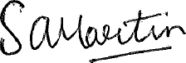

David Allen Sullivan